Game World

Develop a website which can host games which are educational as well as fun.

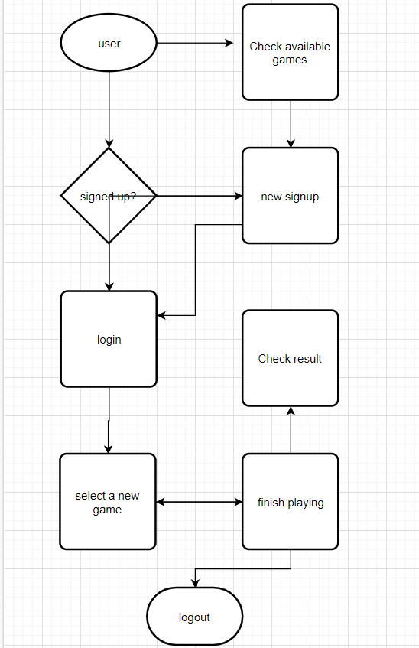

Functionalities

Made by Group E -Sawan P.,Esha G.